**Tata Motors DVR Conversion: What WE AS A Investors Need to Know**

Recently, Tata Motors made a significant decision to convert its Differential Voting Rights (DVR) shares into ordinary shares. This move, approved by 99.8% of shareholders, is pivotal in simplifying the company's capital structure and enhancing investor confidence. As an investor, understanding the implications of this change is crucial for making informed decisions.

**1. Positive Market Reaction:-** Following the announcement, Tata Motors DVR shares surged by 17%. This rise reflects the market's positive reception, primarily driven by the premium offered during the conversion. Investors will receive seven ordinary shares for every ten DVR shares, which translates to a 23% premium on the previous DVR share price.

**2. Simplified Capital Structure:-** The conversion is expected to simplify Tata Motors' capital framework by eliminating the price discount between DVR and ordinary shares. This move is anticipated to improve liquidity, transparency, and overall market capitalization, which is a positive development for long-term investor.

**3. Tax Implications:-** While the conversion offers potential value gains, it's essential to consider the tax implications. The conversion is treated as a 'dividend payout,' subject to dividend distribution tax and capital gains tax, which might affect your net returns depending on your investor category.

**My Analysis and Strategy:-**

Given the favorable premium and the positive outlook on Tata Motors’ share restructuring, holding onto or even increasing your position in Tata Motors shares could be a prudent strategy. The simplification of the capital structure and the elimination of DVRs are likely to enhance shareholder value over time.

**What I Have Learned**

This event underscores the importance of understanding complex financial instruments like DVRs and the potential benefits or risks associated with corporate restructuring. Staying informed and analyzing such developments can significantly impact your investment decisions.

**Impact on Tata Motors share:**

The consolidation of shares is expected to improve earnings per share (EPS) and overall market capitalization, making Tata Motors an even more attractive investment. The

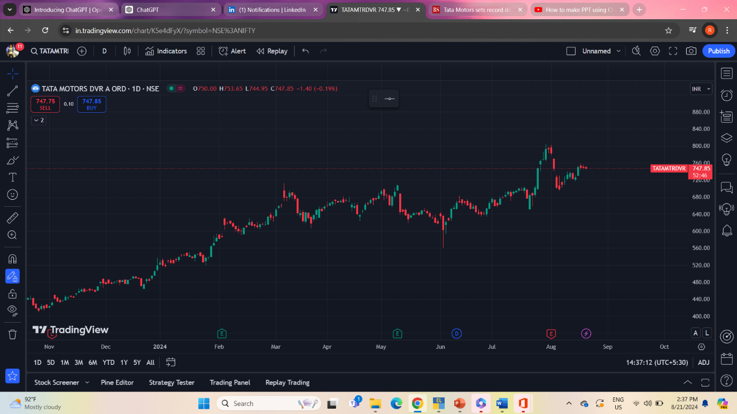

**1. Support Levels**

* **Observation:** The chart shows some clear support levels around INR 740, which the price has tested a few times.
* **Interpretation:** Strong support levels indicate that the share price is unlikely to fall below this point without a significant negative catalyst. Investors may see this as a good entry point if the price stays above this level.

**2. Uptrend Since Early 2024**

* **Observation:** The chart shows a significant uptrend starting from late 2023 through early 2024, indicating that the share price has been steadily increasing.
* **Interpretation:** This suggests growing investor confidence and possibly improving fundamentals in Tata Motors during this period.

**3. Period of Consolidation**

* **Observation:** After a steady rise, the price has moved into a phase of consolidation, particularly visible in June and July 2024.
* **Interpretation:** Consolidation is a common phenomenon after a strong uptrend. It indicates that the market is taking a breather and investors are re-evaluating before the next big move. This could be due to uncertainty or profit-taking by earlier investors